OS

Lab Manual (Lab 4)



Session: Spring 2023

LAB INSTRUCTOR: MUNIB MAJID

**RUN A C++ PROGRAM ON TERMINAL USING GCC COMPILER**

**Follow the following steps to run a program on terminal.**

**Step 1:**

Open terminal.

**Step 2:**

Type command to install gcc or g++ compiler.

$ sudo apt-get install build-essential

This will install the necessary C/C++ development libraries for your Ubuntu to create C/C++

programs.   
$ sudo dpkg --configure -a

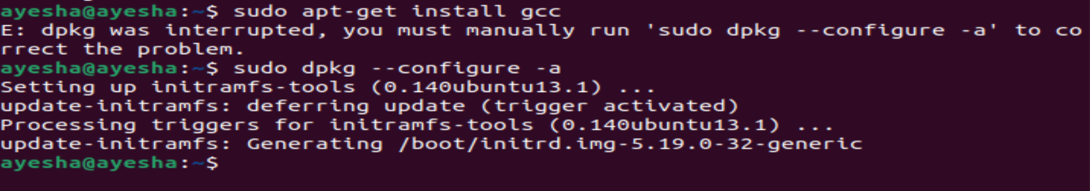

$sudo apt-get install g++

If you are unable to install the above package try the following two methods.

Method 1:

[[Resolved]Unable to fetch some archives, maybe run apt-get update or try with –fix-missing? in Linux | ERROR](https://commandstech.com/resolvedunable-to-fetch-some-archives-maybe-run-apt-get-update-or-try-with-fix-missing-in-linux-error/)

Method 2:

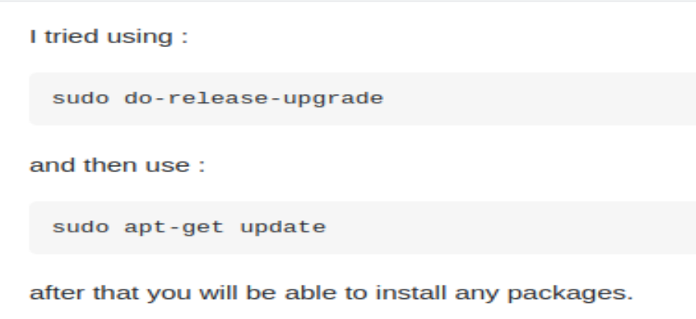

This will install the necessary C/C++ development libraries for your Ubuntu to create C/C++ programs.

To check gcc/g++ version type this command:

$ gcc -v

$g++ -v

**Step 3:**

Now create a directory named cppfiles this is the directory which will be holding all the cpp files that you will be creating in your today’s task.

**Step 4:**

Open a file using.

$ cat > hello.cpp  
You can also use text editor to write cpp file

**Step 5:**

Type your hello world program in the opened document.

**Step 6:**

Save the file and exit.

**Step 7:**

Compile the program.

$sudo g++ hello.cpp

It will create an executable file with “.out” extension named as “a.out”.

Or

$ sudo g++ –o hello hello.cpp

Where hello is the executable or object file of hello.cpp program

**Step 8:**

To run this program, type this command:

For running C++ program

$ ./a.out (If you compiled using first command) Or.

$ ./hello (If you compiled using second command) It will show output on the terminal.

**TASKS:**

1. **Using gcc compiler write down a C++ program to find whether the number is even and odd. Take number as input from the user.**
2. **Print your name, sap id and your current semester using gcc compiler. Do this question via a C++ program.**
3. **Use for loop to print “Operating System” five times.**
4. **Write a C++ program using gcc compiler to check whether the number is positive or negative.**